CREEKSIDE’S TEACHING NOTES for Sunday, June 26, 2016
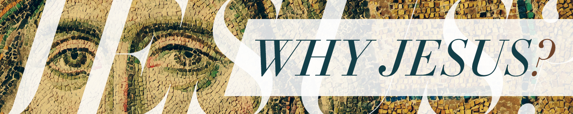

BELIEVING IS SEEING
John 20:1-31

Jesus has been trying to get the disciples
to believe before they see. Because believing before you see is much better than seeing before you believe.

- He has told them repeatedly that he is going to die, be buried and then rise from the dead.
- He simplifies things by saying, “I am going to be gone for a little while and then I am going to come back again.”
- He tells Peter he will deny him.
- He tells them Judas will betray him.
- Jesus is gone when the women and Peter and John get to the tomb.
- The men only see the linens. John believes that Jesus is risen without seeing the risen Jesus.
- Jesus calls Mary’s name and she is drawn to him.
- She runs to tell the disciples but Jesus does not go with her.
- Jesus waits until Sunday evening to appear before the disciples.
- Thomas is not there and without seeing does not believe that Jesus has risen from the dead even though all of the disciples claim he has.
- Jesus stays away until the following Sunday (8 days) before he stands before Thomas. Thomas confesses, “My Lord and my God.”

Then Jesus told him,
“Because you have seen me, you have believed;
blessed are those who have not seen and yet have believed.”
John 1:29

Jesus performed many other signs in the presence of his disciples, which are not recorded in this book. But these are written that you may believe that Jesus is the Messiah, the Son of God, and that by believing you may have life in his name.
John 20:30-31

Seeing is not enough.
You still have to choose to believe.

Then the eleven disciples went to Galilee, to the mountain where Jesus had told them to go. When they saw him, they worshiped him; but some doubted.
Matthew 28:16-17

If I only believe when I can see
what happens to my faith in the dark?

Sight only faith is anemic faith. It is sick faith. It will not stand the test of time and circumstance.

You need to believe when you cannot see for only then will your faith take you through the dark valleys and dark tunnels of life.

Though you have not seen him, you love him; and even though you do not see him now, you believe in him and are filled with an inexpressible and glorious joy, for you are receiving the end result of your faith, the salvation of your souls.
Peter 1:8-9

Consequently, faith comes from hearing the message, and the message is heard through the word about Christ.
Romans 10:17

For in the gospel the righteousness of God is revealed—a righteousness that is by faith from first to last,^{[a]} just as it is written: “The righteous will live by faith.”
Romans 1:17

Hebrews 11

You cannot make yourself believe through willpower.
That kind of belief would be toxic.

You have to choose to believe without being 100% certain.
Faithfulness matters more than certainty.
It just doesn’t feel as good.
John Ortberg

