CREEKSIDE’S TEACHING NOTES for Sunday, April 24, 2016
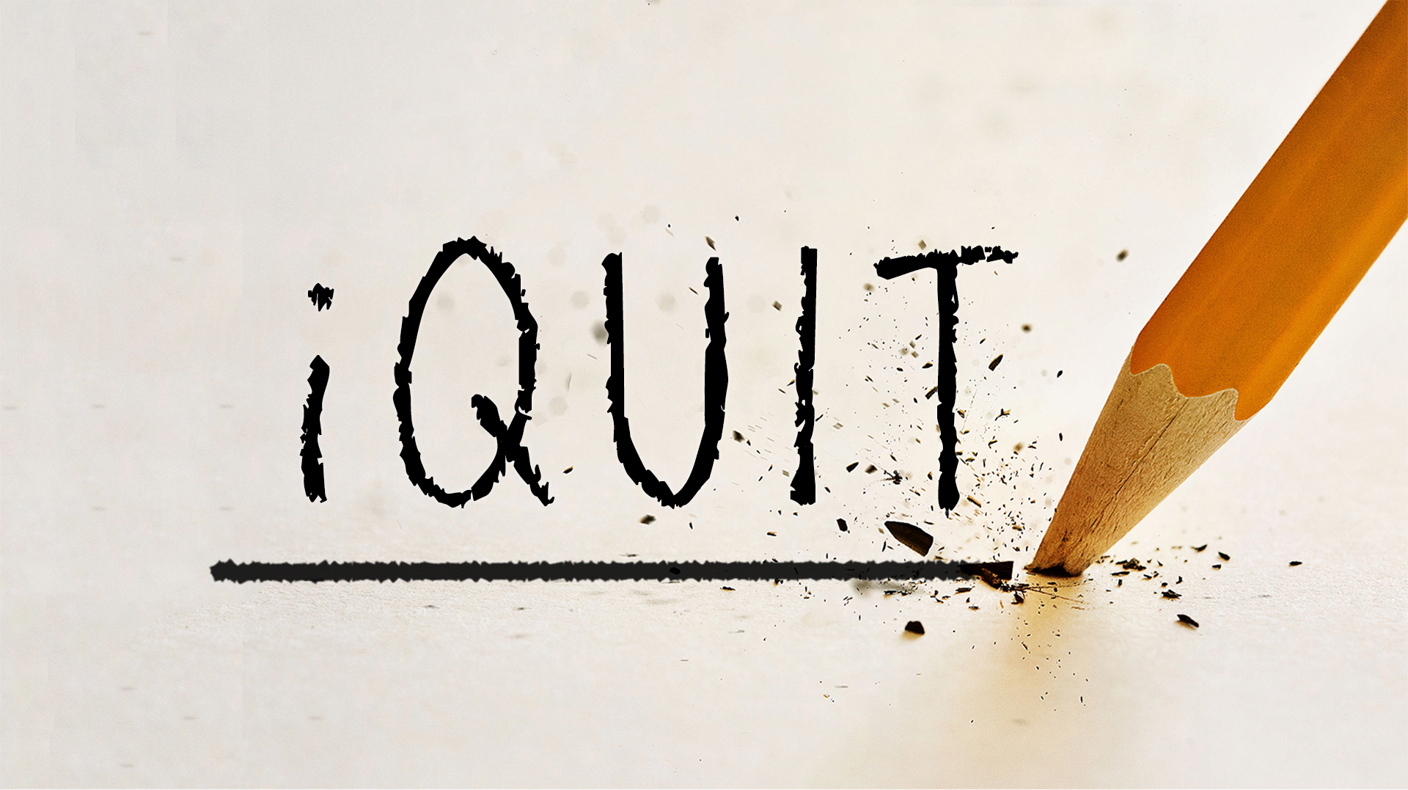

iQuit . . . The Comparing

A peaceful heart leads to a healthy body,
jealousy is like cancer in the bones.
Proverbs 14:30 NLT
At its heart
the motivating force behind jealousy
is the deep seated belief that . . .
“God owes me!”

It is when our hearts are stirred
that we become most aware of what they contain.

JEALOUSY IS A CHOICE.

1 Samuel 18:6-11

When the men were returning home after David had killed the Philistine, the women came out from all the towns of Israel to meet King Saul with singing and dancing, with joyful songs and with timbrels and lyres. As they danced, they sang:
“Saul has slain his thousands,
and David his tens of thousands.”
Saul was very angry; this refrain displeased him greatly. “They have credited David with tens of thousands,” he thought, “but me with only thousands. What more can he get but the kingdom?” And from that time on Saul kept a close eye on David.
1 Samuel 18:6-9

JEALOUSY SHOWS UP IN THREE WAYS IN SAUL’S HEART:

1. Anger:

Saul was very angry; this refrain displeased him greatly.
1 Samuel 18:8
2. Suspicion:

What more can he get but the kingdom?” And from that time on Saul kept a close eye on David.
1 Samuel 18:8-9

All other passions condescend at times to accept the inexorable logic of facts; but jealousy looks facts straight in the face, and ignores them utterly, and says she knows a great deal better than they can tell her.
A Helps

3. Fear:

Saul was afraid of David, because the Lord was with David but had departed from Saul.
1 Samuel 18:12

People are not the source of your problem any more than the moon is a source of light – they are just reflecting back to you what has originated in your heart.
We must celebrate the success of the person over whom our jealousy cloud hangs.

And Jonathan made a covenant with David because he loved him as himself. Jonathan took off the robe he was wearing and gave it to David, along with his tunic, and even his sword, his bow and his belt.
1 Samuel 18:3-4

It’s much easier to behave your way into a new way of thinking than to think your way into a new way of behaving. Don’t wait until you feel like celebrating; celebrate until you feel like it.
Andy Stanley

Choose to celebrate
the blessing you see
in another person’s life.

