CREEKSIDE’S TEACHING NOTES for Sunday, January 19, 2014
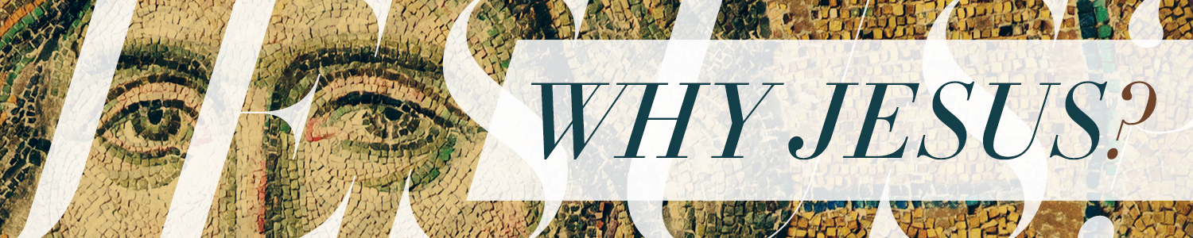

It’s A Worship Thing
John 4:1-42 (p. 980)

We are who we are
because of what we worship.
We do what we do
because of what we worship.

WE ORIENT OUR LIVES AROUND
WHAT WE WORSHIP

When worship is oriented around anything other than God it is idolatry.

²¹ Jesus said to her, “Woman, believe me, the hour is coming when neither on this mountain nor in Jerusalem will you worship the Father. ²² You worship what you do not know; we worship what we know, for salvation is from the Jews. ²³ But the hour is coming, and is now here, when the true worshipers will worship the Father in spirit and truth, for the Father is seeking such people to worship him. ²⁴ God is spirit, and those who worship him must worship in spirit and truth.”
John 4:21-24 English Standard Version

TRUE WORSHIPERS WILL WORSHIP

You shall have no other gods before me.
Exodus 20:3 (p. 70)

The Hebrew word for worship means . . . “to fall or to prostrate yourself before someone, touching your forehead to the earth.”
The NT Gk word Proskuneo . . . “to kiss toward or to kiss the hand” the word used in John 4

The NT Gk word Latreuo . . . “to give or pay homage”

THE FATHER

Ascribe to the LORD glory and strength.
Ascribe to the LORD the glory due his name.
1 Chronicles 16:28-29 (p. 384)

We sing about the Lord so we can better sing to the Lord but it is our ultimate goal to sing to the Lord.
J Macdonald

IN SPIRIT AND IN TRUTH

Absolutely and Accurately

Worship is mind, emotions and will engaged in whole person ascription of worth to God.

My lips will shout for joy, when I sing praises to you.
Shout to God with loud songs of joy!
Psalm 71:23 (538)

To you I lift my eyes, O you who are enthroned
in the heavens!
Psalm 123:1 (p. 572)

Clap your hands, all peoples!
Shout to God with loud songs of joy!”
Psalm 47:1 (p. 524)

Lift up your hands in the sanctuary and bless the Lord.
Psalm 63:4 (p. 532)

Come, let us worship and bow down; let us kneel before the LORD our Maker!”
Psalm 95:6 (p. 553)

FOR THEY ARE THE KIND OF WORSHIPERS THE FATHER SEEKS.

Worship happens
when God experiences me.
Leonard Sweet

