4. Salvation (How to reach our Destiny)

A. Buddhism

Eightfold Path:

Wisdom
Right Understanding
Right Thought
Ethical Conduct
Right Speech
Right Action
Right Livelihood
Mental Discipline
Right Effort
Right Awareness
Right Meditation

B. Christianity

We cannot save ourselves

God saved you by his grace when you believed. And you can’t take credit for this; it is a gift from God. 9 Salvation is not a
reward for the good things we have done, so none of us can boast about it. Ephesians 2:8-9 (NLT)

Jesus is the our Saviour

For the wages of sin is death, but the free gift of God is eternal life through Christ Jesus our Lord. Romans 6:23 (NLT)

CREEKSIDE’S TEACHING NOTES for Sunday, March 15, 2015
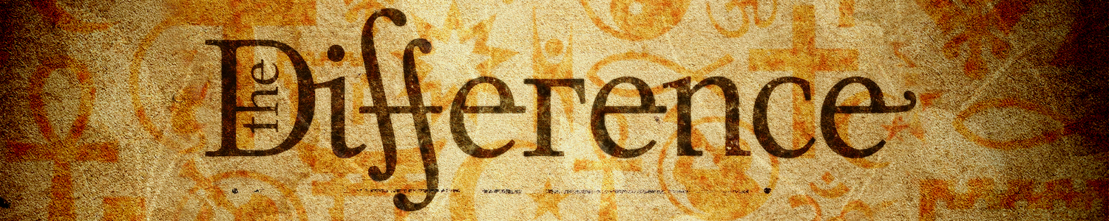
Buddhism
The History of Buddhism
Originated 6th century B.C in India
Founder — Siddhartha Gautama

"Buddha" means "one who is enlightened”

Two major branches of Buddhism:
- Theravada
- Mahayana

Scriptures of Buddhism
- the Tripitaka — writings called "3 baskets”
- the Tripitaka + Contains over 5000 volumes.

Scriptures for Christianity:
Bible comprised of 66 books.

Beliefs Compared:
1. God
A. Buddhism

The Conservative View
Neither deny or affirm God's existence.
The Liberal View
Many Gods.

B. Christianity

There is One True God
Jesus told him. “For the Scriptures say, ‘You must worship the Lord your God and serve only him.’ ” Matthew 4:10 (NLT)
The goal for humanity is to enter into a right relationship with God.

For this is how God loved the world: He gave his one and only Son, so that everyone who believes in him will not perish but have eternal life. John 3:16 (NLT)

2. The Problem with Life

A. Buddhism -- Suffering

Four Truths:
1. Suffering is an essential part of life.
2. The cause of suffering is human desire.
3. The solution to suffering is to eliminate earthly desires,
especially the desire to exist as an individual.
4. The steps to defeat these desires are the "Eightfold Path"

B. Christianity - Sin

Sin is the big problem not desires

Do not let sin control the way you live; do not give in to sinful desires. Do not let any part of your body become an instrument of evil to serve sin. Instead, give yourselves completely to God, for you were dead, but now you have new life. So use your whole body as an instrument to do what is right for the glory of God. Romans 6:12-13 (NLT)

Suffering is a part of life.

Yet what we suffer now is nothing compared to the glory he will reveal to us later…. for we long for our bodies to be released from sin and suffering. We, too, wait with eager hope for the day when God will give us our full rights as his adopted
children,including the new bodies he has promised us….
Romans 8:18-25 (NLT)

Overcoming suffering comes from trusting God

And we know that God causes everything to work together for the good of those who love God and are called according to his purpose for them. Romans 8:28 (NLT)

3. Our Destiny

A. Buddhism

Rebirth (reincarnation)

Karma (action)

Nirvana(release)

B. Christianity

We live and die only once.

And just as each person is destined to die once and after that comes judgment, Hebrews 9:27 (NLT)

We will experience the resurrection.

Just as everyone dies because we all belong to Adam, everyone who belongs to Christ will be given new life. But there is an order to this resurrection: Christ was raised as the first of the harvest; then all who belong to Christ will be raised when he comes back. 1 Corinthians 15:22-23 (NLT)

